------------------------------------------------------------------------------------------------------------------------------------------------------------------------------------------

FIRST CREATE JENKINS MASTER AND INSTALLATION OF

1. **JAVA : openjdk 11.0.23 2024-04-16 LTS**

#yum install java-11-amazon-corretto.x86_64

1. **GIT : git version 2.40.1**

# yum install git -y

1. HTTPD : Server version: Apache/2.4.59

#yum install httpd –y

# systemctl start httpd

# systemctl enable httpd

# systemctl status httpd

**# mkdir server**

**# cd server**

**4 ) Apache Tomcat** :wget <https://dlcdn.apache.org/tomcat/tomcat-9/v9.0.89/bin/apache-tomcat-9.0.89.zip>

# unzip apache-tomcat-9.0.89.zip

# rm -rf apache-tomcat-9.0.89.zip

# chmod -R 777 apache-tomcat-9.0.89/

# cd apache-tomcat-9.0.89/

**5 ) Install jenkins by using .war file**

# cd webapps/

# wget https://get.jenkins.io/war-stable/latest/jenkins.war

# ls -ltr

# cd ..

# cd bin

# ./startup.sh

-------------------------------------------------------------------------------------------------------------------------------------------------------------------------------------------------------------------------------------------------------------------

**This Is Jenkins master..**

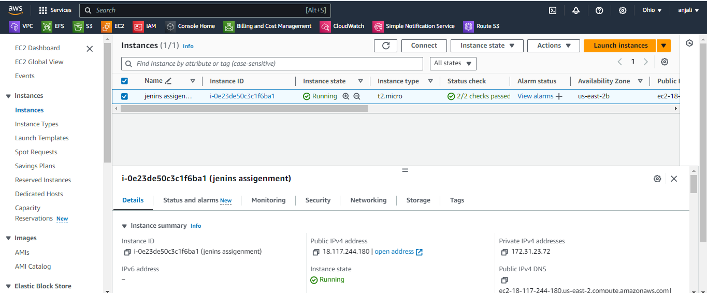

------------------------------------------------------------------------------------------------------------------------------------------------------------------------------------------

After jenkins install and setup n configer JOB as fallow :

First create job : my-first-job-repo-1

Execute shell…..

--------------------------------------------------------------------------------------------------------------------------------------------------------------------------------------------

cd /root/project

rm -rf *

git clone https://github.com/bhagywantanjali/repo-1.git

cd /var/www/html/

rm -rf *

cp /root/project/repo-1/index.html .

chmod -R 777 index.html

------------------------------------------------------------------------------------------------------------------------------------------------------------------------------------------

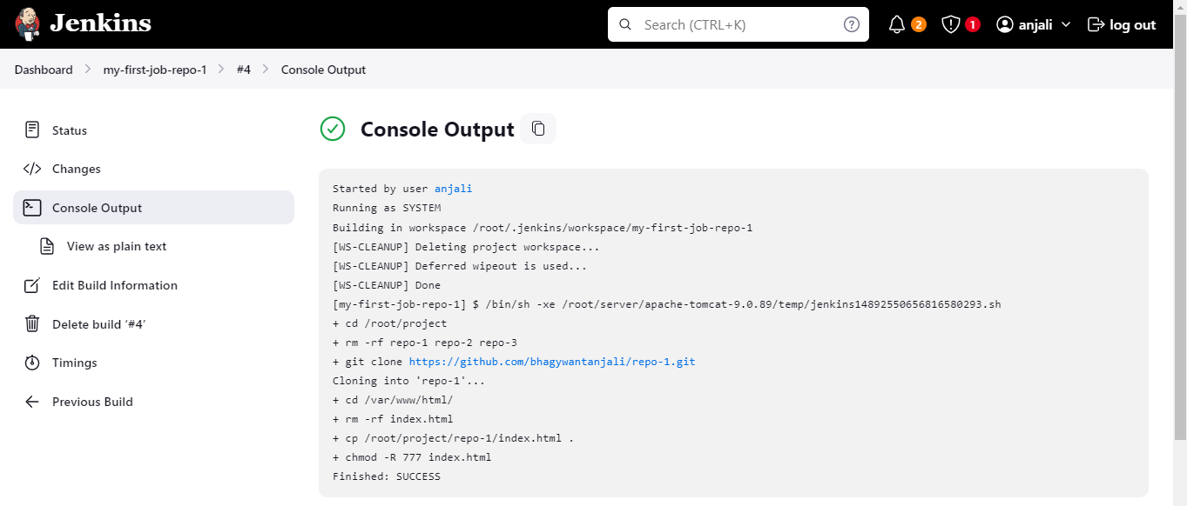

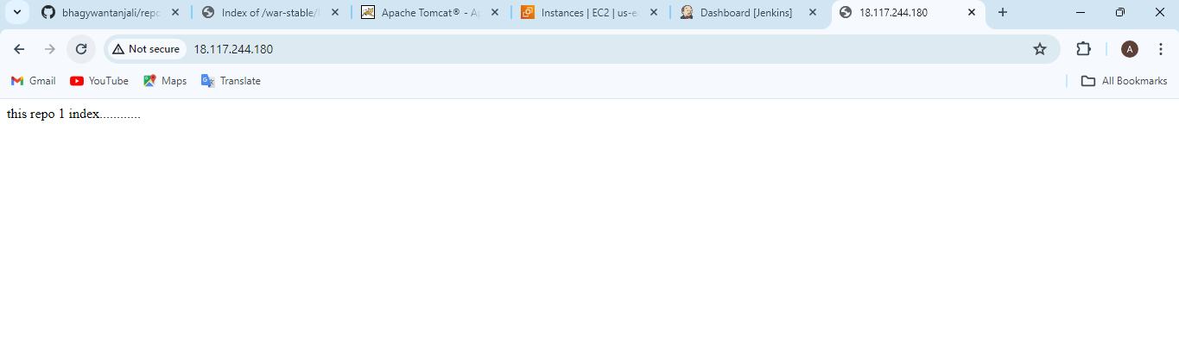

------------------------------------------------------------------------------------------------------------------------------------------------------------------------------------------SECOND JOB :

**second create job : my- second -job-repo-2**

**Execute shell…..**

--------------------------------------------------------------------------------------------------------------------------------------------------------------------------------------------

cd /root/project

rm -rf *

git clone https://github.com/bhagywantanjali/repo-2.git

cd /var/www/html/

rm -rf *

cp /root/project/repo-2/index.html .

chmod -R 777 index.html

------------------------------------------------------------------------------------------------------------------------------------------------------------------------------------------

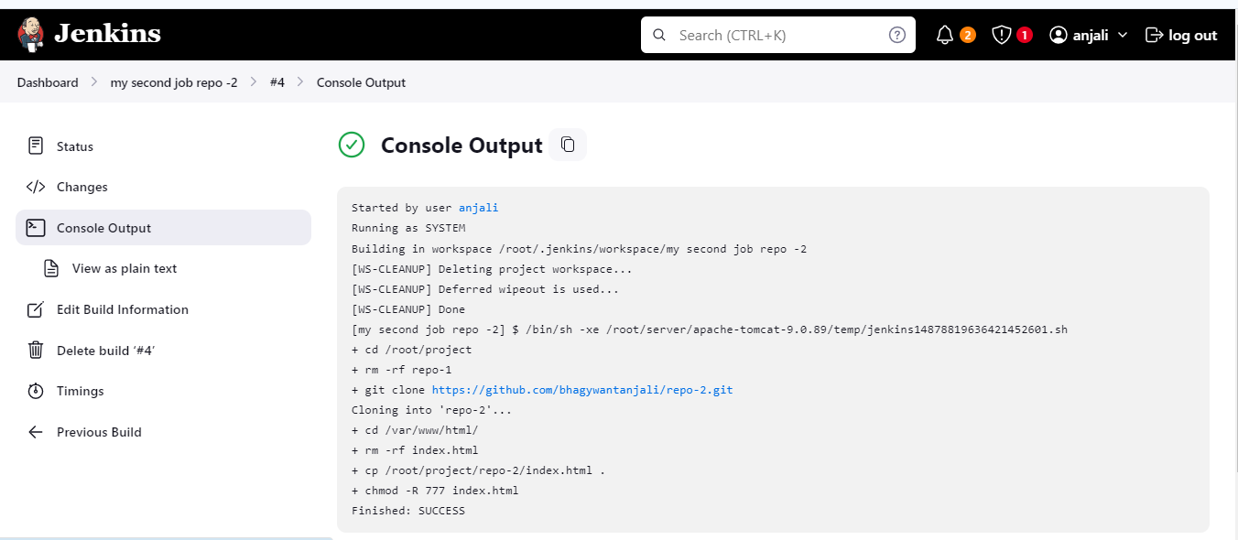

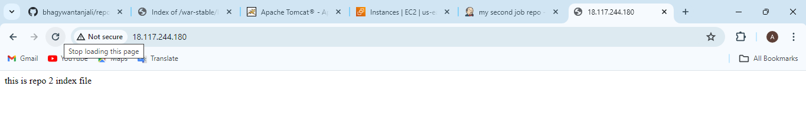

--------------------------------------------------------------------------------------------------------------------------------------------------------------------------------------------

THIRD JOB :

third create job : my- third -job-repo-3

Execute shell…..

--------------------------------------------------------------------------------------------------------------------------------------------------------------------------------------------

cd /root/project

rm -rf *

git clone https://github.com/bhagywantanjali/repo-3.git

cd /var/www/html/

rm -rf *

cp /root/project/repo-3/index.html .

chmod -R 777 index.html

------------------------------------------------------------------------------------------------------------------------------------------------------------------------------------------

